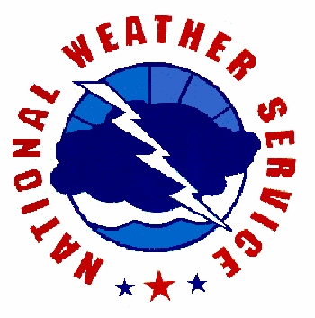
N W S Recommendations When Developing a Severe Weather Emergency Plan for a School

While no plan is storm proof, recommendations provided in this guide are based on safety measures that have been proven to help mitigate the loss of life.

Table of Contents

● Introduction
● SWEP Purpose

●  Section 1: Local Weather Dangers
● Thunderstorm Dangers: Lightning, Hail, Downbursts and Tornadoes
● Floods
● Tropical Storms and Hurricanes
● Temperature Extremes

●  Section 2: Designing a SWEP
● Severe Weather Team and Coordinators
● How to Determine Tornado and High Wind Safety Zones in Your School
● How to Receive Emergency Weather Information
● How Administration Might Alert Faculty and Students to Take Action
● When to Activate Your SWEP and When to Return to Normal Activities
● When to Consider Holding School Buses
● Recommended School Bus Safety Actions
● Special Considerations for Other Weather Hazards
● Periodic Drills and Severe Weather Safety Instruction

●  Appendices
● Appendix A: National Weather Service Products
● Appendix B: Glossary of Weather Terms
● Appendix C: Resources

Updated 1/04/2012 Jillson

Introduction

SWEP Purpose

This guide was designed as a basis for schools when designing their individualized Severe Weather Emergency Plan (SWEP). All weather related situations cannot be covered in this guide, and having a SWEP will not guarantee that your facility is storm proof; however this document will serve as a starting point and a general outline of recommended safety actions when severe weather threatens. You may wish to work with your county Public Safety Office and county Emergency Management when developing your customized SWEP. Recommendations provided in this document may also help enhance the School District’s Emergency Plan. The ultimate goal of a SWEP is to effectively and efficiently warn those at risk of the imminent threat of severe weather and to relocate them to designated safe areas. A clearly written SWEP can enable parents, faculty and students to know how to react when time is critical. A SWEP can provide peace-of-mind that appropriate actions are being done to promote safety. By practicing your SWEP, consistent actions will be reinforced which can save lives when seconds count.

Section 1: Local Weather Dangers

Thunderstorms Dangers

If a thunderstorm produces large hail (≥ 1 inch in diameter), damaging winds (≥ 58 mph) or a tornado, then it is defined as a severe thunderstorm. Severe thunderstorm warnings are not issued for lightning. All thunderstorms produce lightning. Thunderstorms are most common from late spring through early fall during the late afternoon and early evening, but storms can occur at any time of year, anytime of the day.

Thunderstorm hazards and floods can occur rapidly and sometimes with little or no warning. Evacuation decisions should be made quickly and executed immediately if these hazards threaten. We recommend preparing a SWEP now which can save lives when seconds count. Schools may also consider what to do when tropical storms, hurricanes, or excessive heat indices are expected to affect their district. It may also be prudent to address the rare occurrence of winter weather and excessive cold. These weather hazards are not routine in our area and are usually predicted at least a day in advance which can allow decision makers more time to address how the weather may affect school operations.

Lightning

Florida leads the nation in lightning deaths which kills an average of 9 Floridians and injures 37 each year. In Florida, most lightning deaths occur to children ages 10 to 19 years old, and most victims are struck outside including on athletic fields and in swimming pools. Upper level winds can blow the upper level anvil cloud of the thunderstorm miles away from where the storm is producing rainfall. Lightning can emanate from the anvil; in fact, many lightning strike victims are struck by a “Bolt From the Blue” which describes that there is not a cloud overhead when the victim is struck. If you are close enough to a storm to hear thunder, then you are close enough to be struck by lightning.

Hail

Large hail can cause extensive damage to a large area in a short period of time, as well as bodily harm. Some hail stones can descend from the storm at speeds of 100 mph, severely impacting whatever object they strike.

Downbursts

A downburst is a strong wind that descends from a thunderstorm, impacts the ground, and travels at a high speed along the earth’s surface. Downburst winds level objects in their path including telephone and power poles, trees and structures. Objects can become projectiles when blown by downburst winds which could cause severe damage to whatever they strike.

Tornadoes

Tornadoes are violent columns of rotating air that typically develop from severe thunderstorms. The tornado may have surface winds over 200 mph which could lift ground objects and project them in the air. This debris can strike structures causing extensive and possibly deadly damage. Tornadoes can develop very quickly in fast moving thunderstorms, and often there is little time to react when a tornado is approaching. When seconds count, a predetermined evacuation plan to a safe shelter can save lives.

Floods

In Florida, many flash floods occur when poor drainage areas and creeks rapidly overflow with water caused by heavy rainfall over a localized area during a short period of time. These rapidly rising flood waters have moved cars downstream. A flash flood is defined as a rapid rise of high velocity water within 6 hours of the causative event that poses a threat to life and property.

Areal flooding is a common type of flood in Florida and is caused by a gradual rise in water levels over a longer period of time compared to flash floods. Areal flooding can occur when rivers overflow their basins and overspread onto property that is normally free of water. Flood waters can blanket roads and may gradually seep into private residences or businesses. Areal flooding can pose a threat to property, but most areal flooding occurs on long-enough time scales to significantly reduce the threat to life. This type of flood has caused school closures and prevented public transportation including school bus services.

Tropical Storms and Hurricanes

Florida is prone to tropical storm and hurricane landfalls from the Gulf of Mexico and Atlantic Ocean. Tropical systems can produce extreme coastal flooding, flash flooding, and river flooding. This flooding is responsible for the majority of hurricane related fatalities. Winds can gust over 100 mph and tornadoes may develop in rain bands. Local emergency management will decide where and when evacuations are needed.

Several factors influence how a tropical system will affect an area. These factors include the strength, size, forward speed and direction that this storm is moving. Sometimes small tropical systems can be intense and cause extreme destruction over a small area like Category 4 Hurricane Charley in 2004. A slow moving storm can produce a lot of heavy rainfall over a localized area for a prolonged period of time and cause extensive flooding. The direction a storm travels can influence where the higher storm surge will occur, which is usually to the right of center. This is also a favored region for tornado formation, and tornadoes that form in tropical cyclones can develop and move quickly causing small but intense paths of destruction.

Hot Temperature Extremes

The heat index indicates how hot it feels when temperatures and humidity are high. Heat indices can reach dangerously high values and create hazardous conditions for those outside. Heat disorders such as cramps, heat exhaustion and heatstroke are possible from high heat indices. The NWS issues Heat Advisories and Excessive Heat Warnings to warn of dangerously hot conditions.

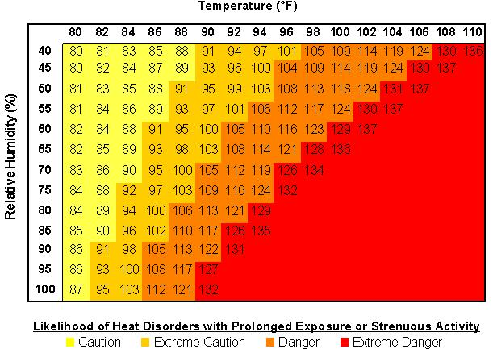

Winter Weather Hazards

A low wind chill temperature is the most common winter threat in our area. Those most susceptible to the cold are young children (under 2 years old) and the elderly (over 60 years old). Some deaths occur from fires started by improper use of alternative heat and light sources such as fireplaces, candles and space heaters. Schools should be aware of extreme cold weather conditions and the impacts on students, especially those waiting for buses and/or those involved in outdoor athletics. The severity of cold exposure to a person is a function of the temperature, wind, the amount of time exposed to the cold conditions and the person’s clothing. The NWS issues Wind Chill Warnings and Advisories when the combination of winds and low temperatures will make it dangerously cold to be outdoors for a prolonged period.

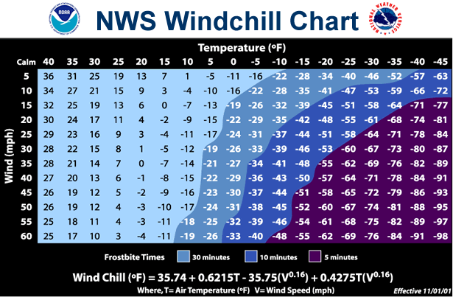

Section 2: Designing a SWEP

Severe Weather Team and Coordinators

We recommend a school "Severe Weather Team" which may include a primary and at least one assistant coordinator. The coordinators would be responsible for developing the customized school’s SWEP. This may involve working with the local school board, administrators and faculty to implement the plan.

How to Determine Tornado and High Wind Safety Zones in Your School

Schools are diverse in design. We recommend that this phase of the SWEP be accomplished with the help of an engineer or architect familiar with the school's design. You may also wish to reference FEMA’s document entitled “Tornado Protection: Selecting Refuge Area in Buildings.” Below, you will find some general guidelines and basic concepts to help you locate safe shelter areas in your school where faculty and students can congregate when hazardous weather is approaching.

Some of the greatest threats from strong winds caused by a tornado, tropical system, thunderstorm downburst or a strong pressure surge behind a cold front include:
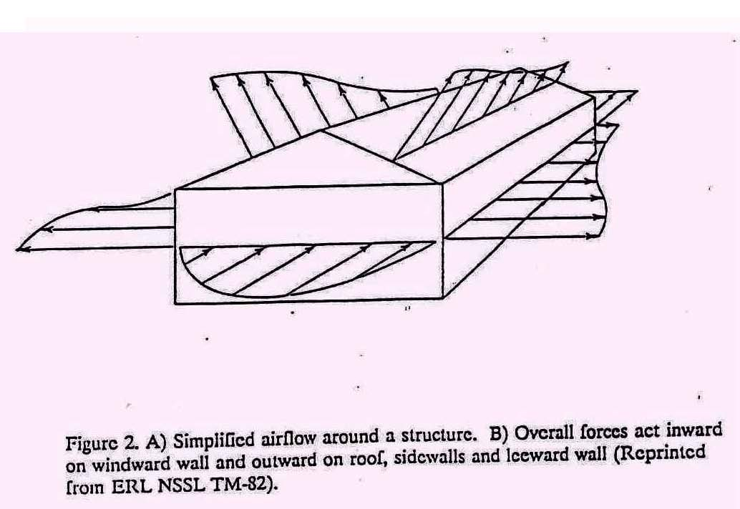
1. Roof failure
2. Breaking glass, and
3. Flying debris (airborne missiles).

Some of the most dangerous locations during strong wind events are generally large rooms with big expansive roofs such as cafeterias, gymnasiums, and auditoriums. The collapse of the room's outer load-bearing wall can lead to the failure of the entire roof. Gravity helps keep roofs attached. When strong winds act on a structure, pressure differences are created causing outward pressures forces that can act to lift the roof. Rooms with large windows that can shatter from airborne missiles or from pressure stresses are extremely dangerous. While windows on the side of the school facing the storm are most susceptible, as the storm passes, any windows could potentially shatter. Once winds enter a building, additional damage is highly likely.

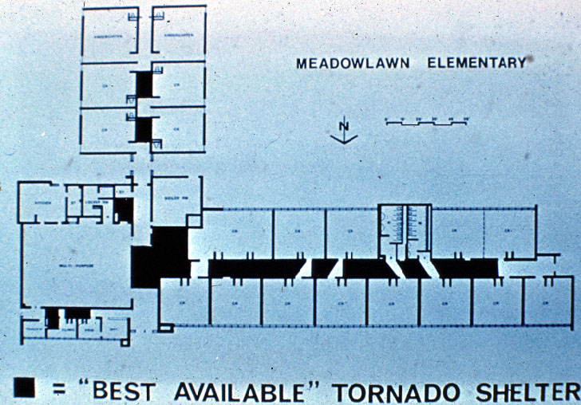
Small windowless interior rooms that are away from exterior doors offer some protection, which include bathrooms and hallways. All doors and windows should be closed, if possible. Interior load-bearing walls (with short roof spans) provide better protection than temporary or non-load-bearing walls. If your school has more than one level, we recommend evacuating the upper floor of the school to the lowest level.

"Open classroom" schools may have a difficult task of finding safe areas due to a lack of interior load-bearing walls, large spanning roofs and the use of a lot of glass. You may not be able to find enough ideal space to occupy your entire faculty and student body. You can, however, find safer locations. Below is a list of vulnerable areas, beginning with the locations that have the highest probability of failure from severe weather:

- Mobile Classrooms
- Rooms with large roof spans (gymnasium, auditorium, cafeteria)
- Windows on exterior walls
- Roof
- Exterior walls of upper level
- Interior walls of upper level; exterior walls of lower level; interior glass; interior, lower level, non-load bearing walls.

You may wish to rank areas of your school according to safety. Next, begin filling the safest areas first with faculty and students and continue down your safe place list until you have found space for the entire school body. We strongly suggest seeking the professional advice of an engineer or architect to locate the safest areas of your school. The safe areas listed above are based on broad generalities.

How to Receive Emergency Weather Information

NOAA Weather Radio (NWR) provides a continuous broadcast of weather information including forecasts, and, if needed, severe watches and warnings. All severe weather watches and warnings tone alert the radio even when it is in ‘silent’ mode. NWRs can be purchased at most retail stores or on-line, and they range in price from $30-$80. Some models have the Specific Area Message Encoder (SAME) feature which allows you to program the radio to tone alert for the counties you choose. The SAME feature uses the county Federal Information Processing Standards (FIPS) code to program which counties you want your radio to tone alert for severe weather watches and warnings. Some NWR models include features such as a link to your public announcement (PA) system, the ability to set off a pager or to call someone, flashing lights for new warnings and a button to play the warning back with a date/time stamp. For more information on the NWR, please visit www.nws.noaa.gov/nwr

Alternative methods to receive NWS warnings include:

- Monitor your local NWS website for real time local information (www.weather.gov). The website will constantly refresh and show the latest watches and warnings.
- Monitor local TV and radio stations for Emergency Alert System (EAS), which include watches and warning from the National Weather Service. EAS operates on a cooperative agreement between broadcasters and federal, state, and local government agencies.
- If you have cable television access, The Weather Channel uses NWS products and broadcasts warnings immediately upon receipt from the NWS via a satellite link. Warnings are continuously scrolled across the bottom of the screen.
- Some cable companies include a channel with a local NWS radar display and use NWR as a voice-over.

Listen for the type of watch or warning and where it is in effect. The severe weather coordinators should know what actions to take based on this information. You may wish to have a local map which details nearby counties and towns you hear broadcast in the warning. There is no need to take emergency action if the warning is not for your location. However, hearing the warning will hopefully heighten your awareness that severe weather may affect your location.

How Administration Might Alert Faculty and Students to Take Action

Most schools utilize a public announcement (PA) system to directly inform faculty and students. In some cases, electricity may be lost during a storm before you have activated your SWEP. You may wish to have a back-up alert device such as a compressed air horn or megaphone.

If your school has portable classrooms, detached gymnasiums and/or cafeterias or another facility that is not connected to the PA, then we recommend making special arrangements to notify these areas of the impending weather hazard. Sending "runners" outside to mobile classrooms is not advisable due to lightning risks. Wireless communication devices are an effective means for such communication. "Walkie-talkies" and cell phones may be the least expensive means of communication.

Handicapped or learning-disabled students may require special attention. You may wish to assign a partner to each special needs student who will insure that the student is transported to an appropriate safe place.

When to Activate Your SWEP and When to Return to Normal Activities

When deciding to activate the SWEP, you will need to determine the type of weather hazard expected as well as the time of impact on your school. A SWEP may work best with phases of activation.

General Thunderstorm Threats including Lightning

Outdoor activities will be the most susceptible to all weather hazards, including lightning. If thunder is heard and/or lightning is seen, outdoor activities should be delayed immediately and students, faculty and spectators moved as quickly as possible into a grounded structure. The delay in activities should last until the storm has safely passed. The 30-30 Rule for Lightning Safety states that everyone should seek adequate lightning shelter if the time between seeing lightning flash and hearing thunder is ≤ 30 seconds. The latter ‘30’ represents waiting at least 30 minutes until after the last rumble of thunder to resume outdoors events.

Severe Thunderstorm or Tornado Watches

A tornado or severe thunderstorm watch means that conditions are favorable in the watch area for tornadoes and severe thunderstorms to develop. If you are in a watch, you may wish to postpone outdoor activities. If a line of storms is approaching your school and you remain under a watch, you may want to proactively move students from the most susceptible areas of your school which may include portables and gymnasiums. For potentially severe thunderstorms, you may want to post teachers or school personnel trained in spotting severe weather to monitor the storms as they approach.

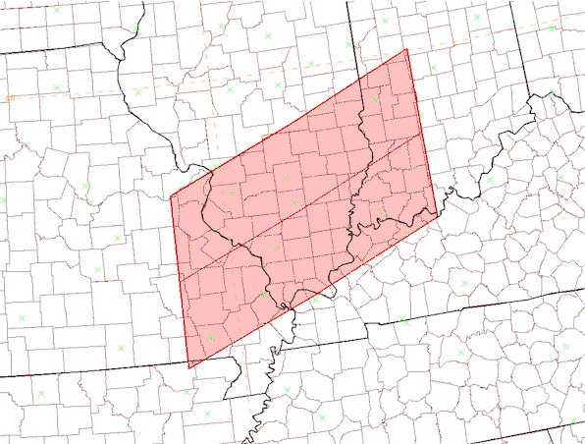
This is an example of a watch box. Normally, severe thunderstorm and tornado watches include a large area which may span many states and include many counties. A watch means that the ingredients to produce severe weather are phasing over the area under a watch. Severe weather could develop in the watch area; keep an eye to the sky and monitor NWR, TV, radio and/or the internet for possible warnings.


Severe Thunderstorm Warning

If a severe thunderstorm warning is issued and the storm is approaching your location, all of the above actions are advised. In addition to strong damaging winds, severe thunderstorms may contain large destructive hail. We recommend relocating faculty and students away from windows and skylights to pre-designated safe areas until the storm passes.

Tornado Warning

If a tornado warning is issued and the tornado is approaching your location, we recommend executing your SWEP immediately and relocating faculty and students to the safest areas of the school. We recommend the ‘Tornado Crouch Position,’ as illustrated above.

If the storm has not yet reached your school, you may wish to move students from relatively unsafe areas and post a trained storm spotter to monitor the storm's approach on internet radar. Your SWEP drills will determine approximately how long it will take to relocate everyone to pre-designated safe areas.

If you did not receive a tornado warning and students and teachers are in class when the classic “freight train” noise is heard, we recommend everyone drop to the floor and under desks and form the ‘Tornado Crouch Position.’

Once the storm has past and the school facility safe, you may wish to return students may to normal activities and locations. Remain alert for the possibility of additional storms especially if you continue under a tornado or severe thunderstorm watch.
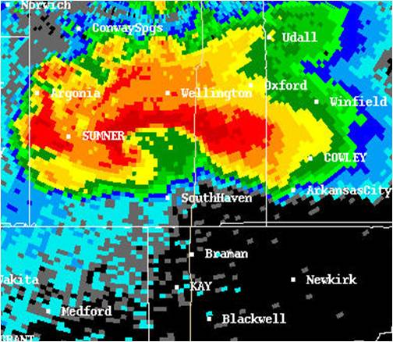
This is an example of a warning polygon. Severe thunderstorm and tornado warnings are issued for much smaller areas compared to watches, and are only issued when severe weather is imminent. If your location resides in the polygon warning, then you should prepare for severe weather in your area. Areas located in the narrowest part of the polygon warning will be the most prone to severe weather within minutes.

When to Consider Holding School Buses

Consider holding the departure of buses when severe weather watches or warning are in effect for your area. There are two primary considerations:

- How long will it take before all students reach home safely? Include the time it takes for students to walk from the bus stop to their home or after school care.
- How much time before the storm impacts your district? Severe weather watches are sometimes issued several hours in advance of thunderstorm development. It may also be a rapidly evolving severe weather situation with less than an hour before severe weather is expected to develop.

If condition number 2 above is less than condition 1, then we recommend delaying the departure of school buses. Although buses may offer adequate shelter from lightning and hail, they do not provide protection from severe winds or tornadoes. You may also wish to consider if your students live in mobile homes. These homes are highly susceptible to high winds regardless if they are anchored or tied down. The school would be a safer place for students compared to a mobile home during a severe storm. We do not advise the dismissal of children during severe weather. We recommend everyone seek a safe location during imminent severe weather.

Recommended School Bus Actions

We recommend that all school bus drivers are trained on how to react during severe weather situations. Encourage drivers to consider safe structures along their routes where they may seek shelter if severe weather is in the area.

Tornado and Severe Wind Safety for School Buses

NEVER ATTEMPT TO OUT-DRIVE A TORNADO!

If a bus driver has reason to believe a tornado is approaching, we advise the following:

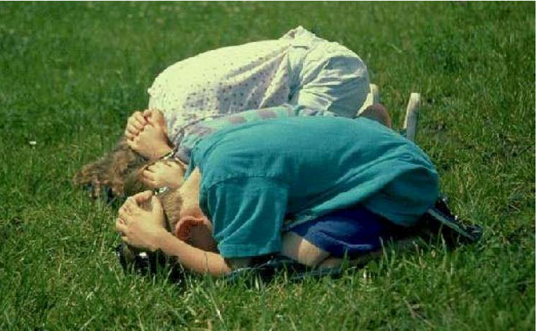
- If time permits, transport students to a well constructed building. Lead them to an interior first floor room away from windows and doors.
- If a well-constructed building is not available, look for a ditch or low lying, un-flooded area. Stop the bus downwind of the selected location to prevent winds from rolling the bus toward students. Unload the bus and lead students to the low area and have them get into the ‘Tornado Crouch Position.’

Flood Safety for School Buses

NEVER ATTEMPT TO DRIVE THROUGH FLOOD WATERS!

If your bus routes traverse small streams, creeks or rivers, we recommend having either an alternate route or a contingency plan to return to the school if flood waters are encountered. River flooding and coastal flooding are generally well forecast with warnings issued early enough that schools and bus drivers can plan their strategy prior to placing the students on the bus. However, flash flooding, which includes a sudden and dramatic rise in fast moving water levels, can occur with little warning.

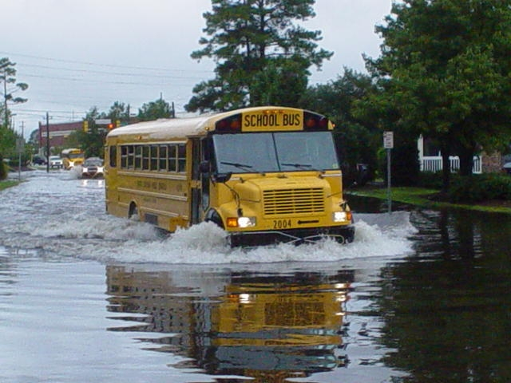
If drivers cannot determine how deep the water is that covers the road, we strongly suggest not passing through it. The road may have been undermined or the water may be deep enough to stall the bus and place all of it occupants in danger. There may also be a sinkhole. We recommend not entering underpasses that are filling with water. If the water appears to be flowing (moving across the road), do not enter. The bus may act as a barrier, and the water may lift and move the bus. If water is flooding over or around a bridge, do not cross it, it could collapse from the weight of the bus. The foundation of the bridge may have been compromised.

Water can rise rapidly and the force of the water against a vehicle, including a school bus, can be powerful enough to move it. If the driver is caught in an unavoidable situation and the vehicle stalls in rising water, we advise that the driver lead all occupants out of the bus immediately to seek higher ground.

Special Considerations for Other Weather Hazards

Tropical Systems

If school is in process when a hurricane or tropical storm strikes, we recommend actions similar to those advised for flooding, lightning, and strong damaging winds. Schools susceptible to river or coastal flooding may be asked to evacuate. Some schools may become shelters for people in flood prone areas or those living in mobile homes.
Excessive Heat

We recommend keeping students out of the sun and reducing or eliminating strenuous activities, even indoors. You may wish to encourage students to drink water and wear light-colored, light-weight clothing. Faculty may wish to learn the symptoms of heat disorders and first aid procedures.

Winter Weather Hazards

In cases of extreme cold, proper clothing is important and should be stressed to students. Outdoor activities may need to be rescheduled or cancelled. Faculty may wish to learn the signs of frost bite and hypothermia as well as first aid for these conditions.

Periodic Drills and Severe Weather Safety Instruction

We strongly recommend periodic severe weather drills and severe weather safety training. Drills not only help students and faculty practice the actions they need to take during a severe weather event, but they will also allow you to evaluate your SWEP's effectiveness and address possible questions that need answers before a real severe weather event approaches your school. You may wish to address the following:

- Did everyone hear the alert message & understand what to do?
- Were they able to get to designated safe areas in a reasonable amount of time?
- Did the designated safe areas accommodate the students and faculty?

We suggest conducting drills in conjunction with a severe weather awareness program. This may help reinforce why sudden safety actions are required when severe weather approaches and hopefully encourage students and faculty to develop severe weather safety plans at home.

The NWS and the Florida Department of Emergency Management (FDEM) conduct a statewide weather awareness week each February. During this week, the NWS, FDEM and local media encourage schools to participate in a coordinated tornado warning drill which includes a test tornado warning from the NWS and the media triggering the Emergency Alert System (EAS). This drill ensures that the warning message is received and will serve as an opportunity for your school to practice your SWEP. We encourage that at least two tornado drills are conducted throughout the school year, preferably more.

Lightning Awareness, Flood Awareness and Tropical Awareness Weeks occur each spring. These weeks may be opportune times for your school to conduct severe weather drills and promote weather awareness education. You can contact your local NWS or emergency management office if you would like a speaker to come to your school and discuss severe weather safety.
Appendices

Appendix A: National Weather Service Products
NWS Tampa Bay Area
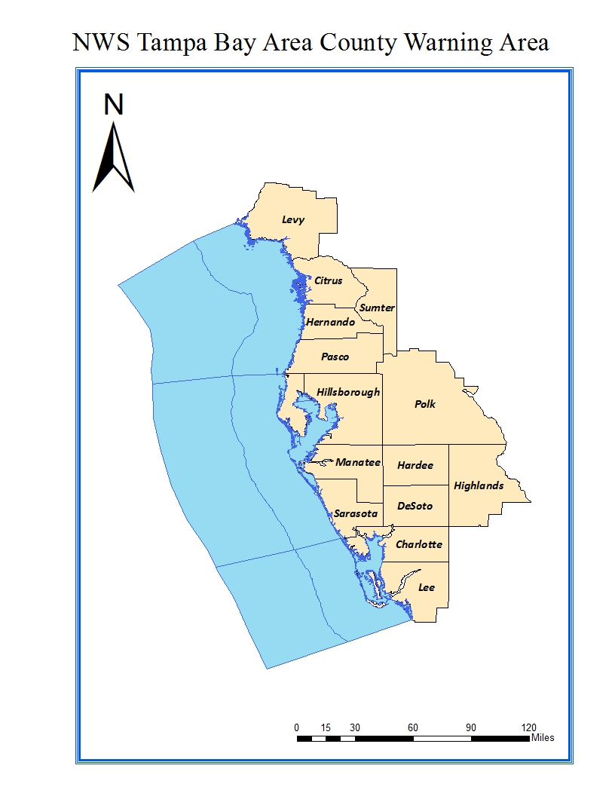
Updated Criteria for Watches, Warnings, Advisories, and Statements
Watch, Warning, Advisory, Statement Criteria Quick Reference
Updated December 6, 2011

Watches (12-48 hours ahead of time)

Coastal Flood Watch | Significant Beach Erosion, moderate coastal Flooding, major high tidal effects.
Excessive Heat Watch | Possibility of Daytime Heat Index reaching 105 AND minimum temp remaining above 80F for 48 hours.
Flood Watch | Widespread areal freshwater  flooding, or widespread estuarine flooding of smaller rivers, streams, or headwaters.
Freeze Watch | Temperature <=32F over a widespread area for at least 2 hours.
Hard Freeze Watch | Temperature 27F over a widespread area for at least 2 hours.
High Wind Watch | Non-thunderstorm: Sustained wind ≥40 mph for one or more hours or Gusts ≥58 mph for any duration, over a widespread area.
Hurricane Watch | Using NHC wind fields for  guidance, will be issued when hurricane force sustained winds or gusts are possible.
Tropical Storm Watch | Using NHC wind fields for  guidance, will be issued when TS force sustained winds or gusts are possible.
Wind Chill Watch | WC Index ≤20 for 3 hours with sustained wind of 10 MPH or higher, over a widespread area (except Levy, Citrus, Sumter, Hernando where WC Index  ≤10).
Winter Storm Watch | Issued to cover the possible occurrence of significant snow, freezing rain/drizzle, or  sleet. See Winter Storm Warning for details.

Long Fused Warnings (12-48 hours ahead of time)

Coastal Flood Warning | Moderate or higher inundation flooding from abnormally high tides.
Excessive Heat Warning | Daytime Heat Index expected to reach 105 AND minimum ambient temperature remaining above 80F for 48 hours.
Flash Flood Warning | Flash flood warnings are issued when flooding is imminent.
River Flood Warning | River Flood Warning issued when streamflow is expected to exceed flood stages of specified gauged locations on area rivers and creeks.
Areal Flood Warning | Widespread areal freshwater flooding, or widespread estuarine flooding of smaller rivers, streams, or headwaters.
Freeze Warning | For minimum shelter (not ground) temperature is expected to be ≤32F for 2 or more hours over a widespread area.
Hard Freeze Warning | For minimum shelter temp of ≤27 for 2 or more hours over a widespread or high population area.
High Wind Warning | Non-Thunderstorm:  Sustained wind of ≥40 mph for one or more hours or Gusts  ≥58 mph for any duration.

Tropical Storm Warning | Using NHC Wind fields for guidance, will be when tropical storm force sustained winds or gusts are expected within the first 30 hours from issuance time.
Wind Chill Warning | WC Index ≤20 for 3 hours with sustained wind of 10 MPH or higher, over a widespread area (except Levy, Citrus, Sumter, Hernando where WC Index ≤10), expected in the first 18 hours from issuance time.
Winter Storm Warning | ≥ 1/2” of snow on roads, any accretion of freezing precipitation on roadways; accretion of ice 1/4" or greater on trees and/or power lines, expected within the first 18 hours from issuance time.
Hurricane Force Warning | Sustained wind, or frequent gusts, ≥64 knots, for non-tropical cyclones, expected in the first 30 hours from issuance time.
Hurricane Warning | Issued when Hurricane Force sustained winds or gusts are expected.

Medium- to Long-Fused Advisories
In general, medium to long fused advisories are issued for expected events in the first (zero to 18 hours from issuance), and sometimes second (12 to 30 hours from issuance), forecast period.

Advisories

Dense Fog Advisory | For visibility reduced to ¼ mile or less over a widespread area due to dense fog, expected within the first 18 hours from issuance time.
Dense Smoke Advisory | For visibility reduced to ¼ mile or less over a widespread area due to dense smoke, expected within the first 30 hours from issuance time.
Wind Advisory | Sustained winds of 30 to 39 mph for one hour or gusts of 40 to 57 mph, expected across a widespread area, within the first 18 hours from issuance time.
Wind Chill Advisory | WC Index 21 to 35 (11 to 25 for Levy, Citrus, Hernando, and  Sumter Counties), with 10 MPH of wind, expected to occur within 18 hours from issuance time.
Winter Weather Advisory | Any light wintry precipitation with expected accumulation on grassy areas but melting on road surfaces, expected to occur within 18 hours from issuance time.
Urban/Small Stream Flood | Minor nuisance flooding problems such as flooding of streets with fair to poor drainage or small creeks and streams. Normally a short fused (2 hours or less) product, but may be issued when event expected to occur within 3 hours from issuance time.

Statements and Outlooks

Medium to Long-Fused Statements

Special Weather Statement | Issued for strong thunderstorms with winds less than 58 mph and/or hail less than 1 inch. Also issued for excessive lightning.
Hazardous Weather Outlook | To provide a general hazardous weather overview for the next 7 days.
Coastal Flood Statement | For above normal tidal effects  causing minor problems for coastal residents, including overwash, “runup”, and rip currents, for expected conditions within the first 18 hours from issuance time.
Flash Flood Statement | To provide additional  information to update an ongoing flash flood warning, or announce  cancellation/expiration of a flash flood warning.
Flood Statement | To provide additional information to update an ongoing river or areal flood warning, or to announce cancellation or expiration of a river/ areal flood warning

Short-Fused Warnings and Advisories (Zero to 2 hours, in general)

Severe Thunderstorm Warning | For imminent occurrence of the following: 1 inch or greater diameter hail; ≥58 mph measured wind gust, or damage expected from wind gusts ≥58 mph.
Tornado Warning | For imminent occurrence of a tornado, based on sound radar  data or trusted ground truth
Flash Flood Warning | For imminent or continuing, significant freshwater flooding  which is a threat to life and property. See Table 1 below for excessive rainfall criteria.
Extreme Wind Warning | Imminent onset of, or occurring, tropical cyclone-related sustained surface winds >= 115 mph. Extreme tropical cyclone winds expected within an hour.
Urban Flood Advisory | For imminent or ongoing occurrence of freshwater urban- type nuisance flooding which is  less than a threat to life/property. See Table 1.
Severe Weather Statement | To update status of tornado or severe thunderstorm warnings. Used to cancel or clear a warning area, or to issue a final expiration message.

Appendix B: Glossary of Weather Terms

Clouds and Thunderstorms
- Thunderstorm (Cumulonimbus): The towering cumulus cloud has continued to grow in height and width and now lightning is occurring. The storm may extend 5-10 miles high into the atmosphere and extend 5-25 miles across. Heavy rain, gusty winds and hail may occur.
- Hail: Precipitation in the form of ice that might descend from a thunderstorm.
- Squall Line: A solid line or band of active thunderstorms.
- Gust Front: The leading edge of rain cooled air that travels along ground away from the precipitation area of a shower or storm. Gusty cool winds and cooler temperatures often accompany a gust front as it moves through an area.
- Shelf Cloud: A low-level, horizontal, wedge-shaped cloud that moves away from the precipitation area of a storm. It forms above the gust front as warm air ahead of the storm the storm rides over the cool outflow from the thunderstorm.
- Wall Cloud: This cloud appears as an isolated lowering of the rain-free base portion of a storm. It is attached to a thunderstorm and may be rotating. This is the portion of the thunderstorm from which a funnel cloud may descend.
- Funnel Cloud: A funnel-shaped cloud extending from a towering cumulus or thunderstorm. It is associated with a rotating column of air that has condensed to form a cloud.
- Tornado: A violently rotating column of air in contact with the ground and extending to the thunderstorm base often seen extending from near the wall cloud. It can be a few yards across to a mile wide.
- Hook Echo: A radar signature that sometimes indicates a tornadic thunderstorm. The rain echo forms the hook pattern as air rotates around the strong updraft. The updraft is the hollow portion of the hook (looks like a ‘6’) and is where the tornado would most likely be found (if the storm were to produce one).
- Downburst: A downward rush of cool air toward ground that can impact with speeds over 60 mph and produce damage similar to that of a tornado. It usually occurs near the leading edge of the storm or may occur in heavy rain. Downburst wind damage levels objects along the ground in the direction that the downburst wind traveled.
  - Microburst : A downburst affecting an area ≤ 2.5 Km in diameter.
  - Macroburst : A downburst affecting an area ≥ 2.5 Km in diameter.
- Severe Thunderstorm: A thunderstorm producing winds ≥ 58 mph and/or hail ≥ 1 inch in diameter.

Tropical Weather
- Tropical Disturbance: A discrete tropical weather system of apparently organized convection -- generally 100 to 300 miles in diameter -- originating in the tropics or subtropics, having a non-frontal migratory character, and maintaining its identity for 24 hours or more. It may or may not be associated with a detectable perturbation of the wind field.
- Tropical Depression: A tropical cyclone in which the maximum sustained surface wind speed (using the U.S. 1-minute average) is 38 mph or less.
- Tropical Storm: A tropical cyclone in which the maximum sustained surface wind speed (using the U.S. 1-minute average) ranges from 39 mph to 73 mph.
- Hurricane: A tropical cyclone in which the maximum sustained surface wind (using the U.S. 1-minute average) is 74 mph or more.
- Storm Surge: An abnormal rise in sea level accompanying a hurricane or other intense storm, and whose height is the difference between the observed level of the sea surface and the level that would have occurred in the absence of the cyclone. Storm surge is usually estimated by subtracting the normal or astronomic high tide from the observed storm tide.
- Storm Tide: The actual level of sea water resulting from the astronomic tide combined with the storm surge.
Floods
- Flash Flood: A rapid and extreme flow of high water into a normally dry area, or a rapid water level rise in a stream or creek above a predetermined flood level, beginning within six hours of the causative event (e.g., intense rainfall, dam failure, ice jam). Ongoing flooding can intensify to flash flooding in cases where intense rainfall results in a rapid surge of rising flood waters.
- River Flood: The rise of a river to an elevation such that the river overflows its natural banks causing or threatening damage.
- Coastal Flood: Flooding which occurs when water is driven onto land from an adjacent body of water. This generally occurs when there are significant storms, such as tropical and extratropical cyclones.
- Urban Flood: Flooding of streets, underpasses, low lying areas, or storm drains. This type of flooding is mainly an inconvenience and is generally not life threatening.
- Bankfull: The water level, or stage, at which a stream, river or lake is at the top of its banks and any further rise would result in water moving into the flood plain.
- Flood Stage: An established gage height for a given location above which a rise in water surface level begins to create a hazard to lives, property, or commerce. The issuance of flood (or in some cases flash flood) warnings is linked to flood stage. Not necessarily the same as bankfull stage.
- Flood Crest: Maximum height of a flood wave as it passes a certain location.

Winter Weather
- Snow: Precipitation in the form of ice crystals, mainly of intricately branched, hexagonal form and often agglomerated into snowflakes, formed directly from the freezing [deposition] of the water vapor in the air.
- Snow Flurries: Snow flurries are an intermittent light snowfall of short duration (generally light snow showers) with no measurable accumulation (trace category).
- Blizzard: blizzard means that the following conditions are expected to prevail for a period of 3 hours or longer:
  - Sustained wind or frequent gusts to 35 miles an hour or greater; and
  - Considerable falling and/or blowing snow (i.e., reducing visibility frequently to less than ¼ mile)
- Sleet: Sleet is defined as pellets of ice composed of frozen or mostly frozen raindrops or refrozen partially melted snowflakes. These pellets of ice usually bounce after hitting the ground or other hard surfaces. Heavy sleet is a relatively rare event defined as an accumulation of ice pellets covering the ground to a depth of ½" or more.
- Freezing Rain: Rain that falls as a liquid but freezes into glaze upon contact with the ground.
- Freezing Drizzle: A drizzle that falls as a liquid but freezes into glaze or rime upon contact with the cold ground or surface structures.
- Ice storm: An ice storm is used to describe occasions when damaging accumulations of ice are expected during freezing rain situations. Significant accumulations of ice pull down trees and utility lines resulting in loss of power and communication. These accumulations of ice make walking and driving extremely dangerous. Significant ice accumulations are usually accumulations of ¼" or greater.
- Wind chill (factor): Increased wind speeds accelerate heat loss from exposed skin. No specific rules exist for determining when wind chill becomes dangerous. As a general rule, the threshold for potentially dangerous wind chill conditions is about -20°F. Thresholds in Florida are warmer because residents are not accustomed to wearing heavy jackets or multiple layers of clothing.
- Freeze: When temperatures at or near the surface (ground) are expected to be 32°F or below. Sometimes used with adjectives "Killing" or "hard". A freeze may or may not be accompanied by frost.
- Frost: Frost describes the formation of thin ice crystals on the ground or other surfaces in the form of scales, needles, feathers, or fans. Frost develops under conditions similar to dew, except the temperatures of the Earth's surface and earthbound objects falls below 32°F. Because frost is primarily an event that occurs as the result of radiational cooling, it frequently occurs with a thermometer level temperature in the mid-30s.
- Hypothermia: A rapid, progressive mental and physical collapse that accompanies the lowering of body temperature.
- Frost Bite : Human tissue damage caused by exposure to intense cold.

Appendix C: Resources

The Florida Department of Emergency Management and the American Red Cross have brochures on developing a "Family Protection Plan." For weather information and preparedness materials, contact your local NWS office. This is the office that has warning responsibility for your area.

Federal Emergency Management Agency: www.fema.gov
Florida Division of Emergency Management: www.floridadisaster.org
American Red Cross National Site: www.redcross.org
National Weather Service National Site: www.weather.gov

Acknowledgements

The NWS in Wilmington, NC, originally developed the StormReady® for Schools Supporter concept. This SWEP guide was originally written by Barbara McNaught Watson, Meteorologist-in-Charge with the National Weather Service, Binghamton NY Forecast Office. It has been adapted for use by the National Weather Service around the country. This version was edited by Ernie Jillson of the National Weather Service Office in Tampa, Florida. While it is designed specifically for schools, this guide may also be applied to various public facilities including businesses, shopping malls, depots, hotels and hospitals.

