2025 State of Indiana
Fire Weather Area Operating Plan




Last Updated: August 19, 2025

INTRODUCTION:

This Fire Weather Annual Operating Plan (FWAOP) was developed to enhance the communication and organization between the National Weather Service offices and various local, state and federal agencies across the state of Indiana. The following National Weather Service offices will provide Fire Weather Planning Forecasts, Spot Fire Weather Forecasts and Red Flag event support to the agencies also listed below. Contact information can be found in Appendix F.

National Weather Service Offices

Office Name (Site ID) | Local NWS Fire Weather Website
Indianapolis (IND) | http://www.weather.gov/ind/fire
Northern Indiana (IWX) | http://www.weather.gov/iwx/fire
Louisville, KY (LMK) | http://www.weather.gov/lmk/fire
Chicago, IL (LOT) | http://www.weather,gov/lot/fire
Wilmington, OH (ILN) | http://www.weather.gov/iln/fireweather
Paducah, KY (PAH) | http://www.weather.gov/pah/fire
NWS Fire Weather Site | http://www.weather.gov/fire
Land Management Agencies

Land Mgmt Agency | Agency Website
State of Indiana DNR | http://www.in.gov/dnr/index.htm
U.S. Fish and Wildlife | http://www.fws.gov/midwest/
Eastern Area Coordination Center (EACC) | http://gacc.nifc.gov/eacc/
U.S. Forest Service | https://www.fs.fed.us
National Park Service | http://www.nps.gov/

Appendices Referenced in this AOP:
- Appendix A: Points of Contact
- Appendix B: NWS Office Coverage for State of Indiana
- Appendix C: NWS National (Experimental) Fire Weather Page and Spot Forecasts
- Appendix D: Experimental Smoke Particle Trajectories
- Appendix E: Examples of Products Issued
- Appendix F: Fire Weather Indices

Definition of Fire Weather Season:

The Fire Weather Season across much of the state of Indiana can vary greatly from north to south. Climatologically, the greatest threat for wildfires and other related fires can occur from late February (southern sections) through April and October through early December (southern sections). However, these are by no means strict starting and ending periods. Throughout the year, land management and National Weather Service officials will evaluate fuel conditions and determine the most favorable time periods for the Fire Weather Season. Additional details on local NWS Fire Weather programs will follow in this plan.

Routine Services provided by the National Weather Service:

Several products are issued by the National Weather Service to aid land management and local fire officials. The formats of the fire weather products will comply with standards set forth in NWS Instruction 10-401 and are standardized in an effort to better serve transient fire fighters.

The following sections will outline the general content and requirements for each product and their issuance. For the sake of brevity, more specific details can be found in NWS Instruction 10-401. Examples of each product can be found in Appendix E.

Fire Weather Planning Forecast (FWF)

The Fire Weather Planning Forecast is issued to provide an overview of expected weather conditions and parameters related to fire weather operations. The product may be broken down on a fire zone by fire zone basis, or may be provided in groups of zones with similar land conditions. Issuance times and frequency of the product varies from north to south and season.

WFO | Frequency During Fire Seasons | Frequency during remainder of the year
Indianapolis | 2x daily (morning and afternoon) | Every morning
Northern Indiana | 2x daily (morning and afternoon) | Every morning between Spring and Fall seasons. No issuance between Fall and Spring seasons
Louisville, KY | 2x daily (morning and afternoon) | Every morning outside Spring and Fall fire seasons.
Chicago, IL | 3x daily (Spring/Fall) | 1x day by 6 am LT
Wilmington, OH | 2x daily (morning and afternoon) | Every Morning and as needed
Paducah, KY | 2x daily (morning and afternoon) Year Round

The morning forecast will contain three periods and an extended portion, while the afternoon forecast will contain four periods and an extended forecast.
The forecasts will contain the following elements:

- Headline - If a Red Flag Warning or Fire Weather Watch is in effect, a headline is mandatory. Outside of these conditions, headlines may be used to convey concerns about significant trends, but are not required.
- Discussion – This is a short paragraph outlining the synoptic features affecting the forecast area during the next 24 to 36 hours.
- Forecast elements will include: cloud cover, chance and type of precipitation, precipitation amount, max and min temperatures and its trend, max and min relative humidity and its trend, 20-foot winds in MPH, mixing height in 1000’s of feet, and transport winds in knots.
- Extended forecast will be appended to the end of the tabular part of the product and will include the winds through day 7.

The following optional forecast elements may be included in gridded data and transmitted in text products at the request of local users. Detailed descriptions of these elements are located in Appendix F.
- Ventilation Index (VI)
- Davis Stability Index (DSI)
- Superfog Indicator (LVORI)
- Atmospheric Dispersion (ADI)

This forecast will be updated whenever the following conditions are warranted.
- A Fire Weather Watch is issued, cancelled or expired
- A Red Flag Warning is issued, cancelled or expired
- When forecast elements are deemed unrepresentative

NFDRS (Point) Forecast
The Point Forecast is issued for a specific point within the fire weather area of responsibility (see stations below) and is valid for a twenty-four (24) hour period after issuance. The format for NFDRS forecast is found in NWS Instruction 10-401.
The following are the points forecasted for during the regular fire weather season.

Station Name | Station Number | Issuance Time and Frequency | NWS Office Issuing
Tipsaw | 128905 | ~ 3 am EST year round, and  3 pm EST during Fire Season | Louisville
Tower | 127901 | ~ 3 am EST year round, and  3 pm EST during Fire Season | Louisville
Hardin Ridge | 125701 | ~ 330 pm EST during Fire Season | Indianapolis
Big Oaks | 127301 | ~ 3 pm EST year round | Wilmington, OH
Bailey | 120201 | ~ 230 pm LST during Fire Season | Chicago, IL
No NFDRS Sites in the State of Indiana |  |  | Paducah  Northern Indiana

Spot Forecasts (FWS)-
Site-specific forecasts (Spot) are issued by an NWS office in support of wildfire and natural resource management. These forecasts aid the land management and fire control agencies in protecting life and property during wildfires, fuel reduction burns, and rehabilitation and restoration of natural resources. Spot forecasts may also be issued for a threat to public safety, including but not limited to hazardous materials incidents, marine incidents, and search and rescue response. However, this plan will focus primarily on forecasts in support of land management agencies.

The forecast elements will typically consist of the highest or lowest temperature during the period, the highest or lowest relative humidity, wind direction and speed, chances and duration of precipitation. Directions for requesting Spot Forecasts can be found in Appendix C.

Experimental Model Particle Trajectories
Land management agencies that have a wildfire of 100 acres or greater, or are conducting a prescribed burn of 100 acres or greater, may request that the National Weather Service run the NOAA Air Resources Laboratory dispersion model, HYSPLIT, to model particle trajectory. This model is a combination of the U.S. Forest Service’s Blue Sky Model and meteorological models used by NWS Forecasters. This data is output in a graphical form and is considered experimental since it is relatively new, and only limited testing has been conducted thus far. This data can be used in addition to a typical spot forecast that is used for Prescribed Burns and Wildfires. More information on the procedures for requesting this and how to interpret the data can be found in Appendix D at the end of this AOP.

Urgent Fire Weather Messages

Fire Weather Watches and Red Flag Warnings (RFW)-
A Fire Weather Watch or Red Flag Warning event occurs whenever extremely dry fuels combine with critical weather parameters to create an atmosphere that could contribute to extensive wildfires with the potential to threaten life and property. Coordination should take place with the affected land management agency for the zone(s) where the watch or warning is being considered. A watch is issued typically up to 96 hour in advance of an event and a warning within 48 hours. A Red Flag warning may also be requested by a land management agency, if they feel that due to extreme dryness in the forest, that wildfires are likely. The Fire Weather Watch or Red Flag Warning can be issued on a county by county basis. The land management agencies and the NWS offices will discuss the area that will be contained within the urgent fire weather message.

The following criteria will be used to determine if Red Flag conditions exist:

(1) Ten hour fuels at 8% or less
(2) Sustained wind averaging >=15 mph (10m ASOS winds) for at least 3 hours (>= 20 mph for Northern/Northwestern Indiana-IWX/LOT (LOT uses 20ft winds))
(3) Relative humidity <= 25 percent for at least 3 hours

Non-routine services:
The National Weather Service will assist any Federal or State agency in training purposes. Typically, the National Weather Service has served as instructors for the weather portions of the S-290 and S-190 hosted by the USFS or DNR. On different occasions, the National Weather Service has also agreed to supply training/instruction support for state and federal agencies in more general purposes, such as seasonal outlooks during late winter staff meetings or regional gatherings. This type of service will continue in the future.

Incident Meteorologists (IMETs)/On Site Support

On site forecast service is a non-routine service available from National Weather Service offices. The NWS will provide IMET services upon request of federal, state, tribal, or local government fire agencies in support of wildfire. The support typically includes dispatches to Incident Command Posts, but may also include dispatches to land management coordination and dispatch centers. IMET support will also be considered for non-wildfire situations, if resources permit. Such uses will be limited to public safety officials who represent such support as essential to public safety (see section 4 of NWS Instruction 10-401. Procedures to request the services of an IMET are detailed in NWS Instruction 10-402.

Wildland Fire Agency Responsibilities:
Agreements and reimbursement between fire agencies and the National Weather Service are outlined at the National Weather Service Fire Weather Page (www.weather.gov/fire).

Effective Date of the AOP:
The AOP will be reviewed by federal and state agencies in coordination with the National Weather Service Fire Weather Program Leader at the respective weather forecast offices every year prior to the start of the spring fire weather season.

Appendix B

NWS Office Coverage for the State of Indiana
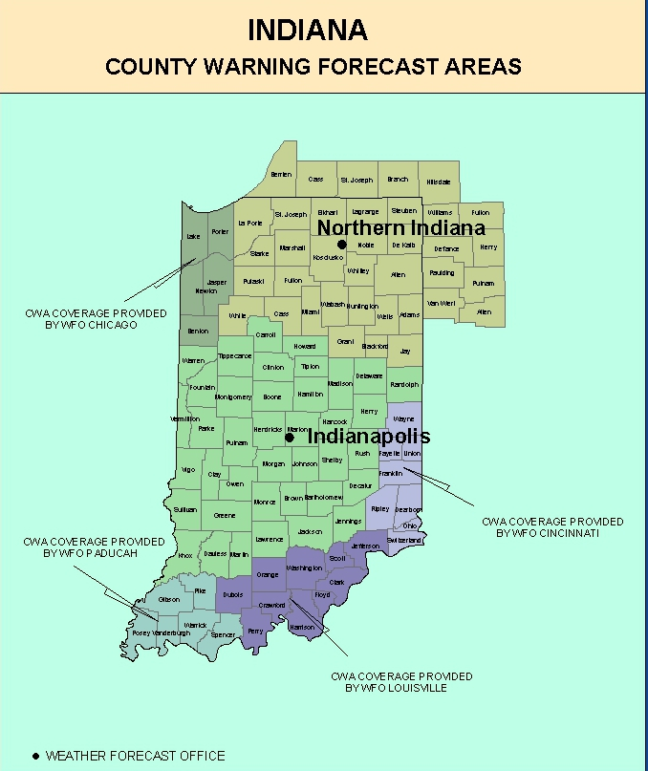
Appendix C

NWS National Fire Weather Page and Spot Forecasts
Graphical and text fire weather products are available through the National Fire Weather Page as well as your local NWS office page. An image of the National page and a link to the page is listed under Figure 1

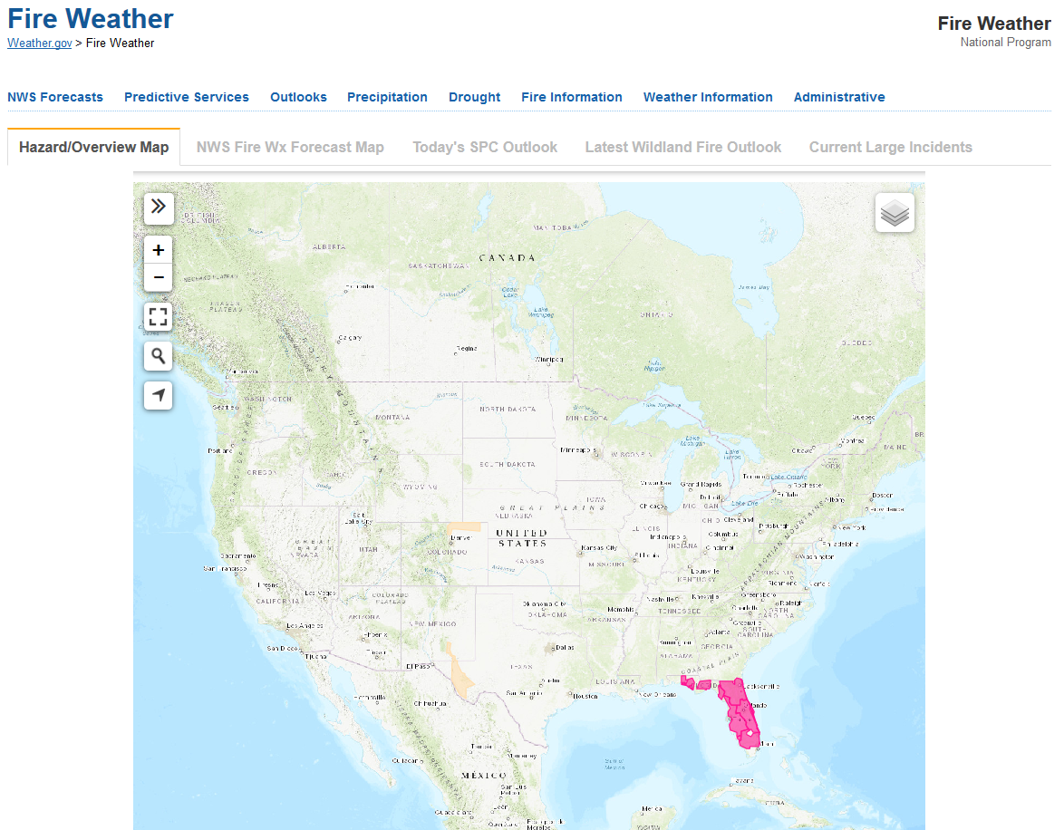

Figure 1: National Fire Weather Page (http://weather.gov/fire/)

Your forecast can be found by zooming in on the map to your point of interest. Left click on the location and a pop-up window will appear similar to Figure 2. Simply select the elements you would like to look at.

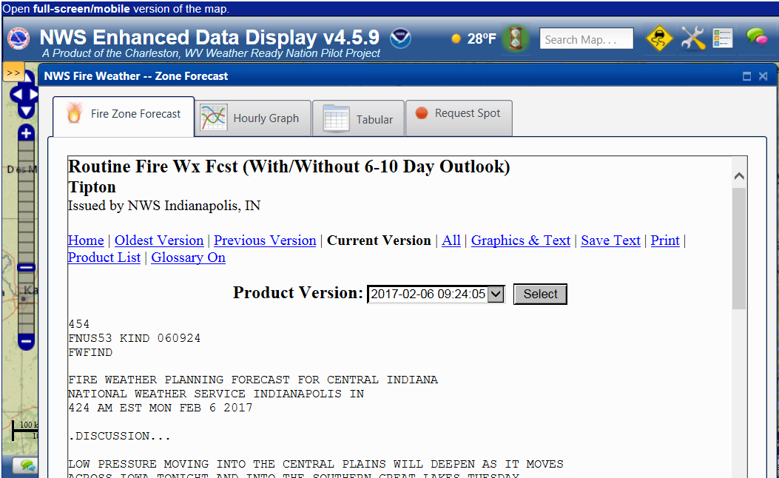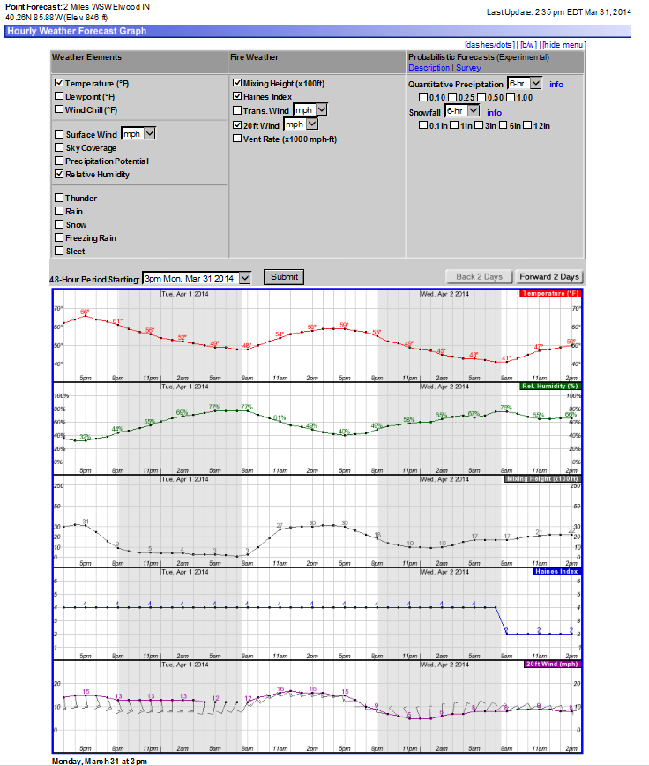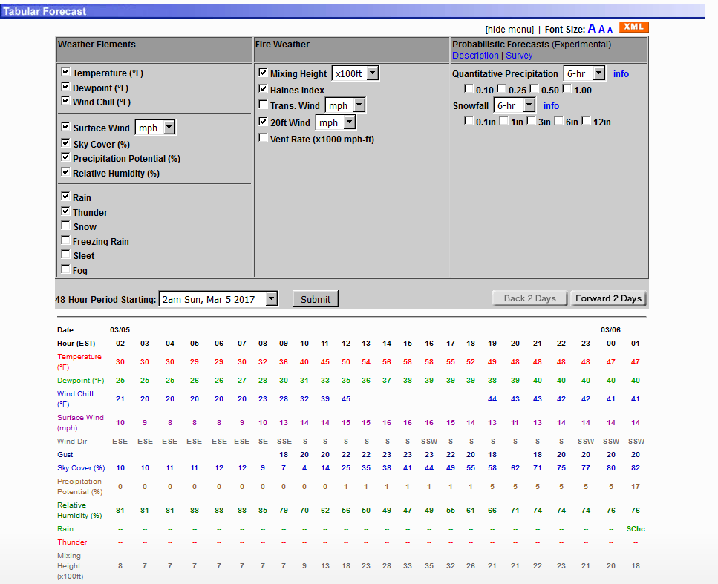

Figure 2: Point and Click Pop-Up Windows

Spot Forecast Request Instructions

Instructions for Submitting a Spot Forecast request via the internet
- Go to the NWS Spot Forecast request page at: https://spot.weather.gov/new-request
- If desired, zoom in to area of interest, then copy and paste link with lat/long info included for later use to skip having to zoom
- Step 1: Enter in location of spot request using street address (Section A), or via lat/long (Section B), or moving the pin on the map (Section B)
- Step 2: Select type of incident (Usually wildfire or prescribed fire)
- Step 3: Click “Generate A Spot Request” button
- Enter Spot Forecast Contact Information, Fire Weather Supplemental Information, Forecast Information, Answer Yes/No to NOAA Hysplit model, Enter observations
- Click Submit request

Retrieving the Spot Forecast
- Monitor the Spot Forecast Monitor page at: https://spot.weather.gov/
- A green pin means the request is still being worked on, red pin means spot is completed
- The forecast can be retrieved by clicking the specific pin, or clicking the spot on the list below the map

Instructions for completing a non-internet Spot Forecast request
- Call your local National Weather Service forecast office.

Appendix D

Overview on NOAA HYSPLIT Model

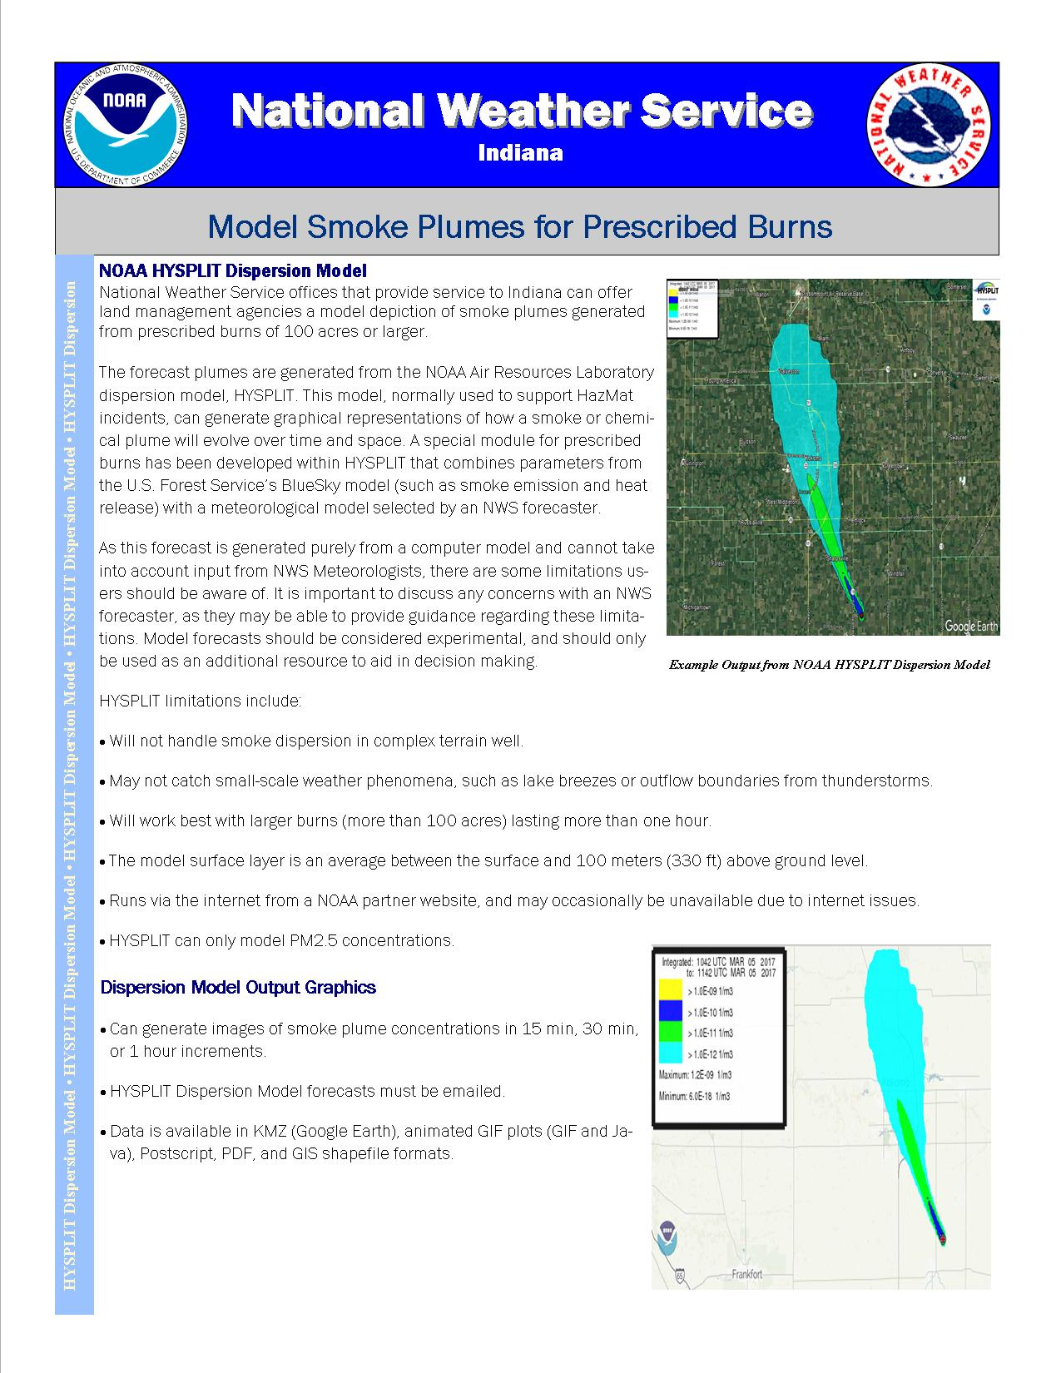
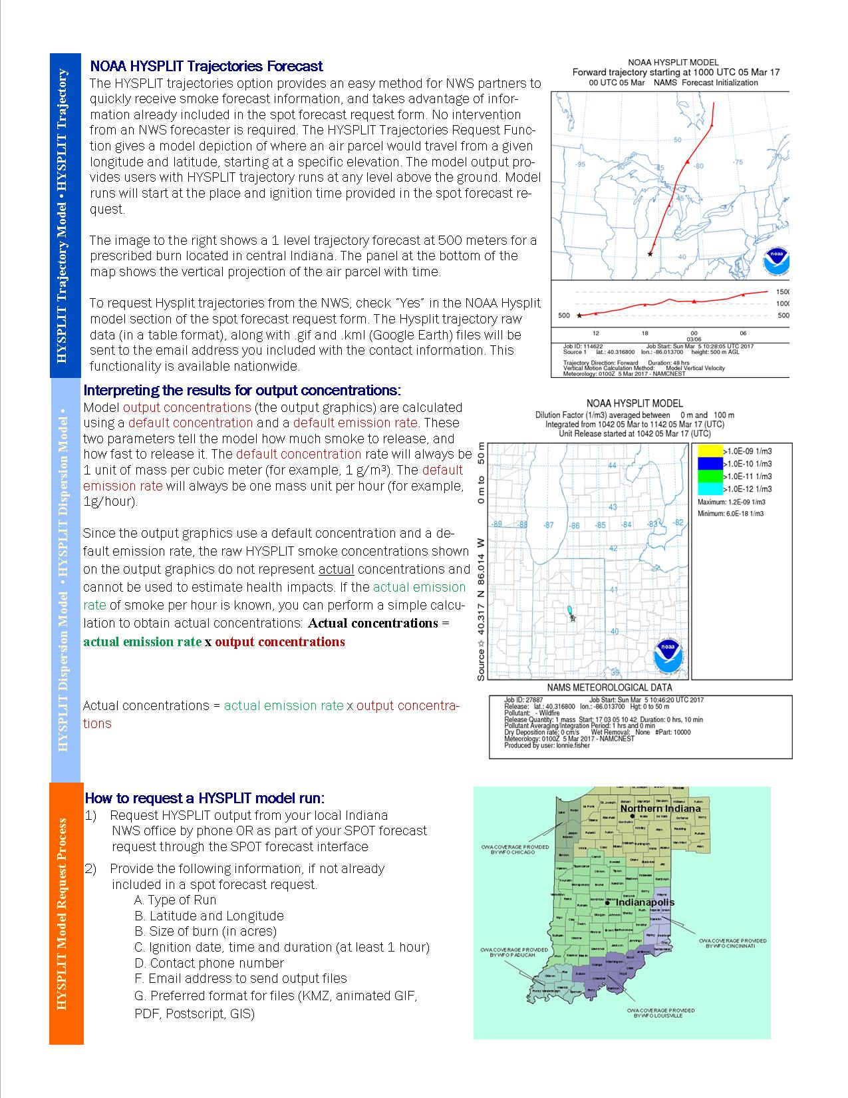

Appendix E

Examples of Fire Weather Products:

Fire Weather Planning Forecast

.DISCUSSION...
The unseasonably warm weather of the last week will come to an
abrupt end Friday evening as a powerful cold front sweeps across the
region. Scattered thunderstorms and the threat for severe weather
will accompany the passage of the front Friday afternoon and
evening. Much colder conditions more typical of late February will
return for the weekend along with the potential for snow showers
late Friday night and Saturday. After a dry Sunday, wet and
unsettled weather will continue through the first half of next week.

INZ062-063-069>071-240915-
Monroe-Brown-Martin-Lawrence-Jackson-
Including the cities of Bloomington, Bedford, and Seymour
324 PM EST Thu Feb 23 2017

.Tonight...
Sky/weather.........Mostly cloudy (70-80 percent).
Min temperature.....Around 60.
24 hr trend......4 degrees warmer.
Max humidity........81-90 percent.
24 hr trend......9 percent drier.
Humidity recovery...Excellent.
20-foot winds.......South 5 to 10 mph.
Smoke dispersal.....Poor to fair (0-50800 knot-ft).
Mixing height.......0-3400 ft AGL.
Transport winds.....South 10 to 15 mph.

.FRIDAY...
Sky/weather.........Mostly cloudy (75-85 percent). Rain showers
likely and chance of thunderstorms after 1300.
Max temperature.....69-75.
24 hr trend......1 degree warmer.
Min humidity........52-61 percent.
24 hr trend......2 percent drier.
20-foot winds.......South 10 to 15 mph.
Smoke dispersal.....Poor to excellent (7200-189700 knot-ft).
Mixing height.......400-6300 ft AGL.
Transport winds.....Southwest 25 to 30 mph.

.FRIDAY NIGHT...
Sky/weather.........Mostly cloudy (70-80 percent). Rain showers and
chance of thunderstorms until 0100.
Min temperature.....Around 35.
24 hr trend......25 degrees cooler.
Max humidity........70-81 percent.
24 hr trend......12 percent drier.
Humidity recovery...Excellent.
20-foot winds.......West around 10 mph.
Smoke dispersal.....Poor to excellent (33800-168500 knot-ft).
Mixing height.......1700-5800 ft AGL.
Transport winds.....West around 30 mph.

.SATURDAY...
Sky/weather.........Mostly cloudy (65-75 percent) until 1800, then
mostly sunny (45-55 percent).
Max temperature.....Around 40.
24 hr trend......31 degrees cooler.
Min humidity........41-48 percent.
24 hr trend......13 percent drier.
20-foot winds.......West around 10 mph.
Smoke dispersal.....Good to excellent (88600-171200 knot-ft).
Mixing height.......4400-6300 ft AGL.
Transport winds.....West 25 to 30 mph.

$$

.FORECAST DAYS 3 THROUGH 7...

.SATURDAY...Mostly cloudy with showers likely and scattered
thunderstorms. Lows in the mid 30s. Highs around 40. West winds
around 15 mph.
.SUNDAY...Partly cloudy. Lows in the mid 20s. Highs in the lower
40s. West winds around 5 mph.
.MONDAY...Mostly cloudy. Chance of snow showers and showers. Lows
in the lower 30s. Highs in the upper 40s. Southeast winds around
5 mph.
.TUESDAY...Mostly cloudy with chance of showers. Lows in the
upper 30s. Highs in the upper 50s.
.WEDNESDAY...Mostly cloudy. Showers likely. Lows in the mid 40s.
Highs in the mid 50s.

$$

Fire Weather Watch/Red Flag Warning (RFW).

Example of Red Flag Warning

...RED FLAG WARNING IN EFFECT FROM 11 AM TO 9 PM EDT THURSDAY FOR
CRITICAL FIRE DANGER FOR ALL OF CENTRAL INDIANA...

THE NATIONAL WEATHER SERVICE IN INDIANAPOLIS HAS ISSUED A RED
FLAG WARNING FOR CRITICAL FIRE DANGER...WHICH IS IN EFFECT FROM 11 AM TO
9 PM EDT THURSDAY. THE FIRE WEATHER WATCH IS NO LONGER IN EFFECT.

* AFFECTED AREA...FIRE WEATHER ZONE 021 CARROLL...FIRE WEATHER
ZONE 028 WARREN...FIRE WEATHER ZONE 029 TIPPECANOE...FIRE
WEATHER ZONE 030 CLINTON...FIRE WEATHER ZONE 031 HOWARD...FIRE
WEATHER ZONE 035 FOUNTAIN...FIRE WEATHER ZONE 036 MONTGOMERY...
FIRE WEATHER ZONE 037 BOONE...FIRE WEATHER ZONE 038 TIPTON...
FIRE WEATHER ZONE 039 HAMILTON...FIRE WEATHER ZONE 040
MADISON...FIRE WEATHER ZONE 041 DELAWARE...FIRE WEATHER ZONE
042 RANDOLPH...FIRE WEATHER ZONE 043 VERMILLION...FIRE WEATHER
ZONE 044 PARKE...FIRE WEATHER ZONE 045 PUTNAM...FIRE WEATHER
ZONE 046 HENDRICKS...FIRE WEATHER ZONE 047 MARION...FIRE
WEATHER ZONE 048 HANCOCK...FIRE WEATHER ZONE 049 HENRY...FIRE
WEATHER ZONE 051 VIGO...FIRE WEATHER ZONE 052 CLAY...FIRE
WEATHER ZONE 053 OWEN...FIRE WEATHER ZONE 054 MORGAN...FIRE
WEATHER ZONE 055 JOHNSON...FIRE WEATHER ZONE 056 SHELBY...FIRE
WEATHER ZONE 057 RUSH...FIRE WEATHER ZONE 060 SULLIVAN...FIRE
WEATHER ZONE 061 GREENE...FIRE WEATHER ZONE 062 MONROE...FIRE
WEATHER ZONE 063 BROWN...FIRE WEATHER ZONE 064 BARTHOLOMEW...
FIRE WEATHER ZONE 065 DECATUR...FIRE WEATHER ZONE 067 KNOX...
FIRE WEATHER ZONE 068 DAVIESS...FIRE WEATHER ZONE 069 MARTIN...
FIRE WEATHER ZONE 070 LAWRENCE...FIRE WEATHER ZONE 071 JACKSON
AND FIRE WEATHER ZONE 072 JENNINGS.

* WINDS...WEST 10 TO 20 MPH WITH GUSTS UP TO 30 MPH.

* TIMING...MID MORNING THURSDAY INTO EARLY THURSDAY EVENING.

* RELATIVE HUMIDITY...AS LOW AS 23 PERCENT.

* TEMPERATURES...90S MOST OF THE TIME BUT MAXIMUM 100 TO 105.

* LIGHTNING...NONE.

* IMPACTS...MOST OF THE COUNTIES IN CENTRAL INDIANA ARE ALREADY
UNDER BURN BANS DUE TO THREAT OF WILDFIRE SPREAD.

PRECAUTIONARY/PREPAREDNESS ACTIONS...

A RED FLAG WARNING MEANS THAT CRITICAL FIRE WEATHER CONDITIONS
ARE EITHER OCCURRING NOW...OR WILL SHORTLY. A COMBINATION OF
STRONG WINDS...LOW RELATIVE HUMIDITY...AND WARM TEMPERATURES WILL
CREATE EXPLOSIVE FIRE GROWTH POTENTIAL.

Appendix F

Fire Weather Indices Explanations:

Ventilation Index:
This index is found by multiplying the mixing height (feet) with the transport wind speed (mph), then dividing by 100 (Final Value has no units).

Value | Dispersal
Less than 130 | Poor
130-299 | Fair
300-599 | Good
600 or more | Excellent

Examples
Mixing height = 14,000 feet Mixing height = 5,000 feet
Transport wind = 15 mph Transport wind = 10 mph
VI = 14,000 * 15 / 100 = 2100 VI = 5,000 * 10 / 100 = 500

A ventilation index of zero implies no ability for the atmosphere to disperse smoke or pollutants, while a value of 600 or greater implies an excellent ability to disperse smoke or pollutants. The United States Forest Service and Department of Natural Resources has requested that when the VI is “fair”, that we include a number value along with the term.

Dispersion:

Dispersion indicates the forecast smoke dispersion category. (4 knots = 4.6 mph; 8 knots = 9.2 mph; 12 knots = 13.8 mph)

Value | Interpretation | Wind Speed
1 | Very Poor | ≥ 4 knots
2 | Poor | > 4 and ≤ 8 knots
3 | Good | > 8 and ≤ 12 knots
4 | Excellent | > 12 knots

Dispersion Index:

The Dispersion Index is a number that gives a relative indication of how well smoke will disperse in the atmosphere. It is calculated by taking the Mixing Height divided by 1000 and then multiplying the result by the transport winds in knots. See the table below for an interpretation for a given Dispersion Index value.

Value | Interpretation
>100 | Very Good
60-100 | Good
41-60 | Fair to Good
21-40 | Fair
13-20 | Poor to Fair
7-12 | Poor
1-6 | Very Poor

Partner Requested Indices (Specific to certain forecast offices)

Davis Stability Index (DSI) (Used by NWS Louisville and Paducah):

The Davis Stability Index is a common fire stability index parameter utilized primarily in the southeast United States. The formula for the Davis Stability Index is as follows:

Davis Stability Index (DSI) = Max Temp (deg C) - 850mb Temp (deg C)
- If the difference is less than 10 deg C, it is considered a Category 1 or stable.
- If the difference is 10 deg C to 14 deg C, it is considered a Category 2 or conditionally unstable.
- If the difference is 15 deg C to 17 deg C, it is considered a Category 3 or unstable.
- If the difference is greater than 17 deg C, it is considered a Category 4 or absolutely unstable.

Ventilation Rate (Vent Rate) (Not Used by Wilmington)

The Vent Rate is a number that gives a relative indication of how well smoke will disperse in the atmosphere.

Vent Rate (kt-ft) = Mixing Height (ft) * Average Transport Winds (kt)
Excellent | >= 150,000 kt ft | >= 23445 m*m/sec
Very Good | >= 100,000 kt ft and < 150,000 kt ft | >= 15630 m*m/sec and <23445 m*m/sec
Good | >= 60,000 kt ft and < 100,000 kt ft | >=9378 m*m/sec and <15630 m*m/sec
Fair | >= 40,000 kt ft and < 60,000 kt ft | >=6252 m*m/sec and <9378 m*m/sec
Poor | <= 40,000 kt ft | <=6252 m*m/sec

LVORI (WFO Louisville only)

(Also known as the superfog indicator) Stands for Low Visibility Occurrence Risk Index (LVORI) is derived from the Lavdas ADI and the relative humidity, which gages the probability of visibility restrictions in fog or smoke. There are 10 LVORI categories; ranging from 1 (indicating the lowest probability of visibility restrictions) to 10 (indicating the highest probability of visibility restrictions). Technical details can be found at http://nwafiles.nwas.org/digest/papers/1995/Vol20-Issue1-Oct1995/Pg26-Lavdas.pdf

Lavdas Atmospheric Dispersion Index (ADI) (WFO Louisville only)
Atmospheric dispersion is the process by which the atmosphere mixes and transports particulates, such as smoke, away from their source. The Atmospheric Dispersion Index (ADI) was developed by the U.S. Forest Service to assess the impact of prescribed burning activity on atmospheric smoke concentrations and air quality. The same processes responsible for good smoke dispersion also contribute to erratic fire behavior and may present very hazardous conditions. A more in depth description can be found in the technical publication posted at http://www.srs.fs.usda.gov/pubs/rp/rp_se256.pdf.

Interpretation of Daytime ADI Values
ADI | DESCRIPTION
0-20 | Poor dispersion, stagnant if persistent.
21-40 | Poor to fair, stagnation may be indicated if accompanied by low wind speeds.
41-60 | Generally Good
61-80 | Very good dispersion. 75 and above, Control problems likely.
80 + | Excellent dispersion, Control problems expected.

Interpretation of Nighttime ADI Values
ADI | DESCRIPTION
0-2 | Poor
3-4 | Poor to Fair
5-8 | Good
8 + | Very Good

Adjective Smoke Dispersal (WFO Louisville Only)

Poor < 29000 < Marginal < 38000 < Fair < 50000 < Good < 95000 < Excellent

