Fire Weather Operations Plan
National Weather Service Honolulu

CONTENTS
Introduction
Contact Information
NWS Policies and Services
Fire Weather Planning Forecast
Red Flag Program
Spot Forecasts
Appendices

INTRODUCTION
This plan documents policies and services provided by the National Weather Service (NWS) Forecast Office in Honolulu, Hawaii for the support of fire management and response agencies in the state of Hawaii.

This plan will be reviewed annually by all parties. Any intermediate changes or amendments will be coordinated with all parties involved before the changes are incorporated.

CONTACT INFORMATION
Personnel vital to the Fire Weather program may be contacted at the following email addresses and/or phone numbers.

National Weather Service
2525 Correa Road Suite 250
Honolulu, Hawaii 96822
http://weather.gov/hawaii
http://www.prh.noaa.gov/hnl/pages/firewx.php
Phone: 808-973-5286

Christopher Brenchley, Meteorologist-in-Charge, 808-973-5272
email: chistopher.brenchley@noaa.gov

Derek Wroe, Fire Weather Program Leader
email: derek.wroe@noaa.gov

John Bravender, Warning Coordination Meteorologist, 808-973-5275
email: john.bravender@noaa.gov

State of Hawaii
Fire Management Officer, DLNR

Deputy Chief Eric Moller – Big Island PTA
email: eric.moller@us.army.mil

NATIONAL WEATHER SERVICE POLICIES AND SERVICES
The National Weather Service Forecast Office in Honolulu, Hawaii provides forecasts, watches, warnings, and consultation services for the prevention, suppression, and management of forest and rangeland fires in the State of Hawaii. The forecast office is located on the campus of the University of Hawaii at Manoa in the Hawaii Institute for Geophysics (HIG) building.

The National Weather Service issues a standard fire weather planning forecast daily with event-driven updates issued as necessary. Fire Weather Watches and Red Flag Warnings are issued to alert land management agencies to the potential for widespread ignitions or control problems with existing fires. Spot forecasts for government agencies involved in fighting currently burning wildfires or soon-to-be ignited prescribed burns are provided on request.

FIRE WEATHER PLANNING FORECAST
The Fire Weather Planning Forecast is issued daily by 530 AM Hawaii Standard Time and is updated at any time on an event-driven basis. Fire Weather Planning Forecasts are available on the web at http://www.weather.gov/hawaii under the Fire Weather section. A depiction of the fire weather zones is included in Appendix A of this document.

The Fire Weather Planning Forecast includes a discussion covering locations of fronts and systems which produce the weather along with anticipated significant trends or changes, a 2-day tabular forecast separated into 3 periods (TODAY, TONIGHT, TOMORROW), which covers the specific weather elements mentioned below, and a narrative extended forecast which continues through day seven. The extended portion is a general forecast, which mentions the possibility of precipitation, expected high and low temperatures for each day, and wind speed and direction.

Elements of the fire weather planning forecast are described below.

- SKY COVER
Daytime Expression | Nighttime Expression | Predominant Opaque Sky Cover (Percent)
SUNNY | CLEAR | 0 to 5 %
SUNNY | MOSTLY CLEAR | > 5 and ≤ 25 %
MOSTLY SUNNY | PARTLY CLOUDY | > 25 and ≤ 50 %
PARTLY SUNNY | MOSTLY CLOUDY | > 50 and ≤ 69 %
MOSTLY CLOUDY | MOSTLY CLOUDY | > 69 and ≤ 87 %
CLOUDY | CLOUDY | > 87 and ≤ 100%

- WEATHER
a) Drizzle: Very small (diameters of less than 0.02 inch), numerous, and uniformly distributed water drops that may appear to float while following air currents. Unlike fog droplets drizzle falls to the ground.
b) Haze: A suspension in the air of extremely small, dry particles, which, individually, are invisible to the naked eye. When numerous, they can restrict visibility.
c) Rain: Liquid precipitation, either in the form of drops larger than 0.02 inch, or smaller drops which, in contrast to drizzle, do not appear to float while following air currents.
d) Showers: Precipitation characterized by the suddenness with which it starts and stops, by the rapid changes of intensity, and usually by rapid changes in the appearance of the sky.
e) Thunderstorms-- A local storm produced by a cumulonimbus cloud(s) accompanied by lightning and thunder, usually with gusts of wind, heavy rain, and sometimes with hail.

- LIGHTNING ACTIVITY LEVEL
Lightning Activity Level, LAL, will be used to forecast the general likelihood for thunderstorms.
LAL 1 - No thunderstorms.
LAL 2 – Isolated thunderstorms. Light rain will occasionally reach the ground. Lightning is very infrequent, with 1 to 5 cloud to ground strikes in a five-minute period.
LAL 3 – Widely scattered thunderstorms. Light to moderate rain will reach the ground. Lightning is infrequent, with 6 to 10 cloud to ground strikes in a five minute period.
LAL 4 – Scattered thunderstorms. Moderate rain is commonly produced. Lightning is frequent, with 11 to 15 cloud to ground strikes in a five-minute period.
LAL 5 - Numerous thunderstorms. Rainfall is moderate to heavy. Lightning is frequent and intense, with greater than 15 cloud to ground strikes in a five-minute period.
LAL 6 – Dry lightning (same as LAL 3 but without rain). This type of lightning has the potential for extreme fire activity.

- MAX AND MIN TEMPERATURE
The maximum or minimum temperature in degrees Fahrenheit during a given time period.

- MAX AND MIN RELATIVE HUMIDITY
Relative Humidity (RH), in percent, the ratio of the amount of moisture in the air compared to the amount the air could hold if fully saturated (100%). The range of RH is from 0% to 100%. Usually, the minimum RH occurs at the time of the maximum temperature and the maximum RH occurs at the time of the minimum temperature. Because of the dependency of the relative humidity upon temperature, it should be noted that if the actual temperature is higher than forecast, then the forecasted relative humidity will likely be too high.

- 20-FOOT WIND - DIRECTION AND SPEED
The wind direction is the direction from which the wind blows. Direction is listed using 8 points of the compass (e.g. NE, S, SW, etc.), or in complex terrain slope or valley oriented wind direction (upslope/downvalley, etc.) can be used. Significant changes expected during the forecast period will be mentioned in the narrative. Wind speed is given in miles per hour (mph) and is forecast for the 20-foot level. Speeds pertain to ten-minute averages while gusts pertain to the maximum instantaneous value expected.

- SMOKE MANAGEMENT FORECAST PARAMETERS
Note: One consequence of the Clean Air Act is that land managers must practice principles of careful smoke management. This is done by combining favorable meteorological conditions with a variety of prescribed fire techniques so that smoke will be readily dispersed. The Clean Air Act has established 500 meters (1700 feet) as a minimum for mixing height for permitting prescribed burning.
a) Mixing Height: The height, in feet above ground level, to which a parcel of air, or a column of smoke, will rise, mix or disperse. A column of smoke will remain trapped below this height.
b) Transport Wind: The average wind over a specified period of time within a mixed layer near the surface of the earth. Usually a wind of less than 8 mph restricts an agency from burning. Transport wind directions are given using 8 points of the compass.

RED FLAG PROGRAM
Forecasters will issue Fire Weather Watches/Red Flag Warnings when the combination of dry fuels and weather conditions support extreme fire danger and/or fire behavior. These conditions alert land management agencies to the potential for widespread new ignitions or control problems with existing fires, both of which could pose a threat to life and property. Extreme fire behavior in Hawaii is typically characterized by a wind-driven fire with high rates of spread that create control difficulties.

Red Flag event criteria consist of both fuel and weather parameters, and to simplify identification of Red Flag events, forecasters will use fuel and weather data from the Honolulu International Airport (PHNL) as their primary source of information. The Keetch-Byram Drought Index (KBDI), which is derived from temperature and rainfall data at the PHNL, is used to diagnose fuel conditions. A Red Flag event will be triggered for leeward portions of the state when all three of the following criteria are met for two hours or more during any part of a day at the Honolulu International Airport (PHNL):
- KBDI ≥ 600
- Minimum RH ≤ 45 % (2 hours or more)
- Wind ≥ 20 mph (≥ 17 kt) (2 hours or more)

Fire Weather Watch:
Fire Weather Watches are issued to alert fire and land management agencies to the possibility of red flag conditions beyond the first forecast period (12 hours). The watch can be issued 18 to 96 hours in advance of the expected onset of criteria. The term “FIRE WEATER WATCH” will be headlined in the routine fire weather forecast.

Red Flag Warning:
A Red Flag Warning is used to warn of an impending or occurring red flag event. Its issuance denotes a high degree of confidence that weather and fuel conditions consistent with red flag event criteria are occurring or will occur in 48 hours or less. The term “FIRE WEATER WATCH” will be headlined in the routine fire weather forecast. The duration of a Red Flag Warning should not exceed 48 hours.

SPOT FORECASTS
Site-specific (spot) forecasts are issued in support of wildfire management, and natural resource management. These forecasts aid the land management and fire control agencies in protecting life and property during wildland fires, hazardous fuels reduction, and rehabilitation and restoration of natural resources. Spot forecasts are also issued for hazardous materials incidents and other threats to public safety.

Spot forecasts are non-routine, near term (typically not more than 48 hours) products issued at the request of the user. Spot forecasts are produced upon request of any federal, state, tribal, or local official who represents the spot forecast is required to support a wildfire. For non-wildfire purposes, resources permitting, WFOs will provide spot forecast service under the following circumstances and conditions:
a. Upon request of any federal official who represents that the spot forecast is required under the terms of the Interagency Agreement for Meteorological Services.
b. Upon request of any state, tribal, or local official who represents that the spot forecast is required to carry out their wildland fire management responsibilities in coordination with any federal land management agency participating in the Interagency Agreement for Meteorological Services.
c. Upon request of any public safety official who represents the spot forecast is essential to public safety, e.g. due to the proximity of population centers or critical infrastructure. A “public safety official” is an employee or contract agent of a government agency at any level (federal, state, local, tribal, etc.) charged with protecting the public from hazards including wildland fires of whatever origin and/or other hazards influenced by weather conditions such as hazardous material releases.

WFOs will not provide spot forecasts to private citizens or commercial entities not acting as an agent of a government agency.

At or before the time of a spot request, the requesting agency should provide incident information: (lat,lon), topography and elevation, and a contact name(s) and telephone number(s) of the requestor. Also, representative observation(s) at, or near, the site of the planned controlled burn, or wildfire, should be available prior to the issuance of the spot forecast.

Requests for spot forecasts are preferably conducted through the Honolulu Spot Forecast Request page (http://spot.nws.noaa.gov/cgi-bin/spot/spotmon?site=hfo), which is available via the Fire Weather section of the NWS Honolulu web page. Requests for spot forecasts may also be made via telephone or fax. For fax requests, phone notification of request required. The NWS fax spot forecast request form is located in Appendix C of this documen. Spot forecasts can be delivered via fax, e-mail, or internet upon request. Unless otherwise stated by the requesting agency, the forecast parameters of sky condition, weather, temperature, relative humidity, 20-foot wind, significant/sudden changes in wind speed or direction, along with mixing heights, and transport winds are provided.
NWS Spot Forecasts can include, upon request, model trajectories from the Hybrid Single Particle Lagrangian Integrated Trajectory (HYSPLIT) model. For more information, please refer to the “NEW FOR 2012” section on the first page of this document.

Appendix A: Fire Weather Zone Maps for Hawaii

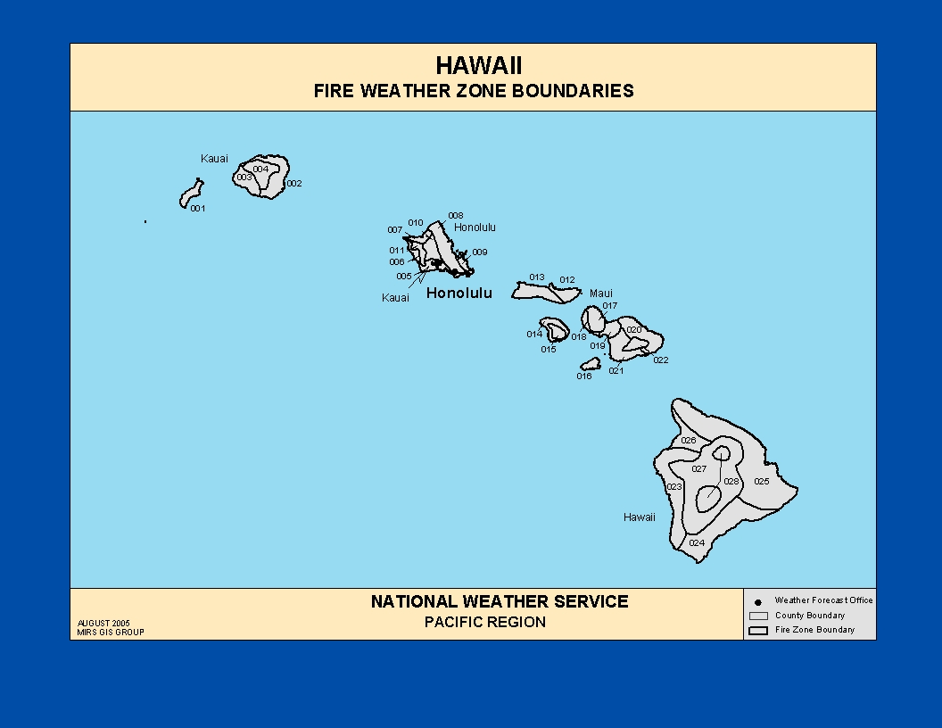

Appendix B: Fax Spot Forecast Request Form D-1

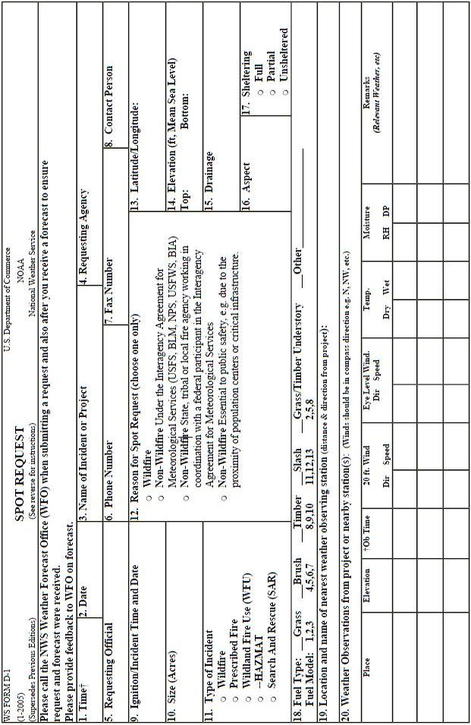

Appendix C: Fire Weather Observation Sites – RAWS sites in Hawaii

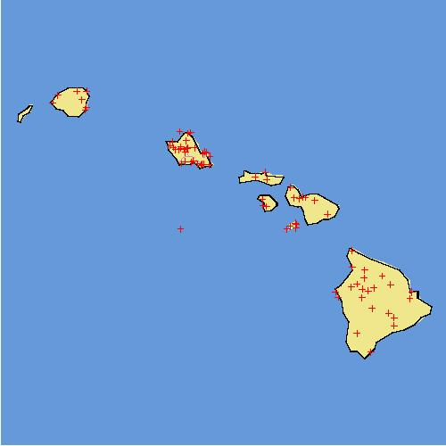

Links to RAWS data:

- MESOWEST:
http://mesowest.utah.edu/cgi-bin/droman/mesomap.cgi?state=HI&address=&type=&noho=&rawsflag=3
- WRCC:
http://www.wrcc.dri.edu/wraws/hiF.html

